**Multicore Programming**

**E E 382C**

Guillermo Leon gel494

Van Quach vq533

Andy Yang dy2443

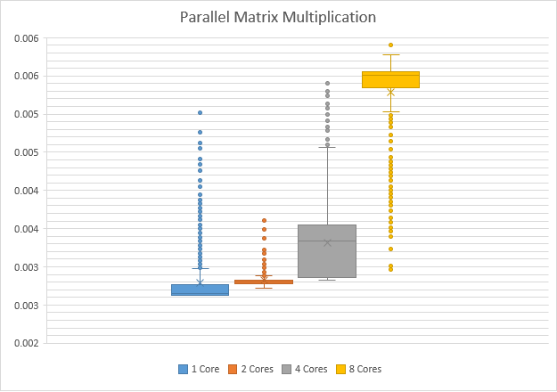

Plot shows execution time in **seconds** of 1000 iterations of 100 by 100 matrices with different number of threads. Tests were run in an Intel Core i7 4980HQ @ 2.8ghz. The processor is quad-core with hyperthreading which gives it 8 logical cores (8 Threads)

This is a box and whiskers chart, which shows the bottom horizontal line as the 1st quartile, horizontal line in the middle of the box is the 2nd quartile and the 3rd one is the last horizontal line. The cross in each one is the mean and finally the extra dots are the outlier points.

If you were to run the tests you can do it with the compiled version of matrix_mult.c passing a 0 as the number of threads. This would print directly to stdout the number of threads and execution time in seconds of each iteration.

Example:

**./matrix_mult matrix1.in matrix2.in 0**